EXPERIMENT LIST FOR PROGRAMMING ABILITY AND LOGIC BUILDING – 1
Name: Krish Panthri
Batch : 2CSE8
Roll Number: 2410031338
Week: 19/1/26 - 25/1/26
Lecture : 2

EXPERIMENT 1
Given an array arr, rotate the array by one position in clockwise direction.
Examples:
Input: arr[] = [1, 2, 3, 4, 5]
Output: [5, 1, 2, 3, 4]
Explanation: If we rotate arr by one position in clockwise 5 come to the front and
remaining those are shifted to the end.
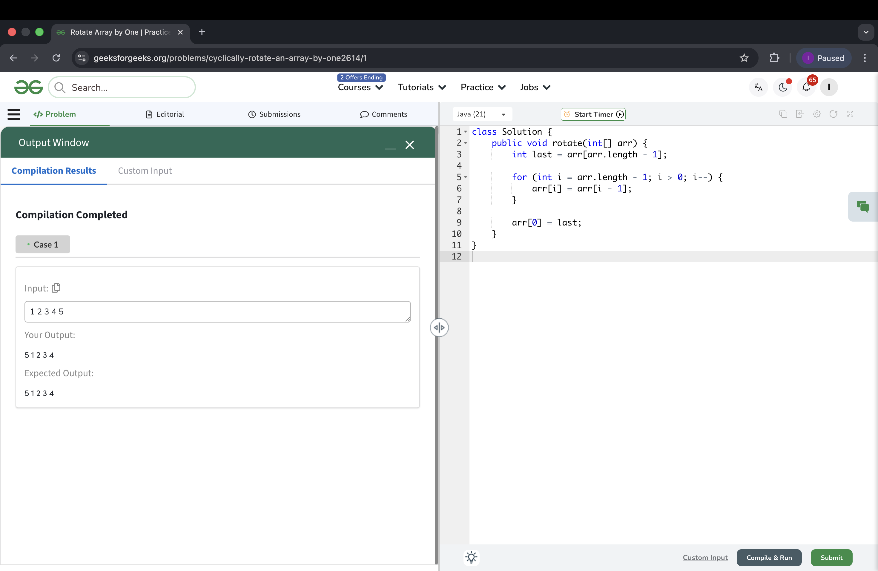

EXPERIMENT 2
You are given an integer array arr[]. You need to find the maximum sum of a
subarray (containing at least one element) in the array arr[].
Note : A subarray is a continuous part of an array.
Examples:
Input: arr[] = [2, 3, -8, 7, -1, 2, 3]
Output: 11
Explanation: The subarray [7, -1, 2, 3] has the largest sum 11.
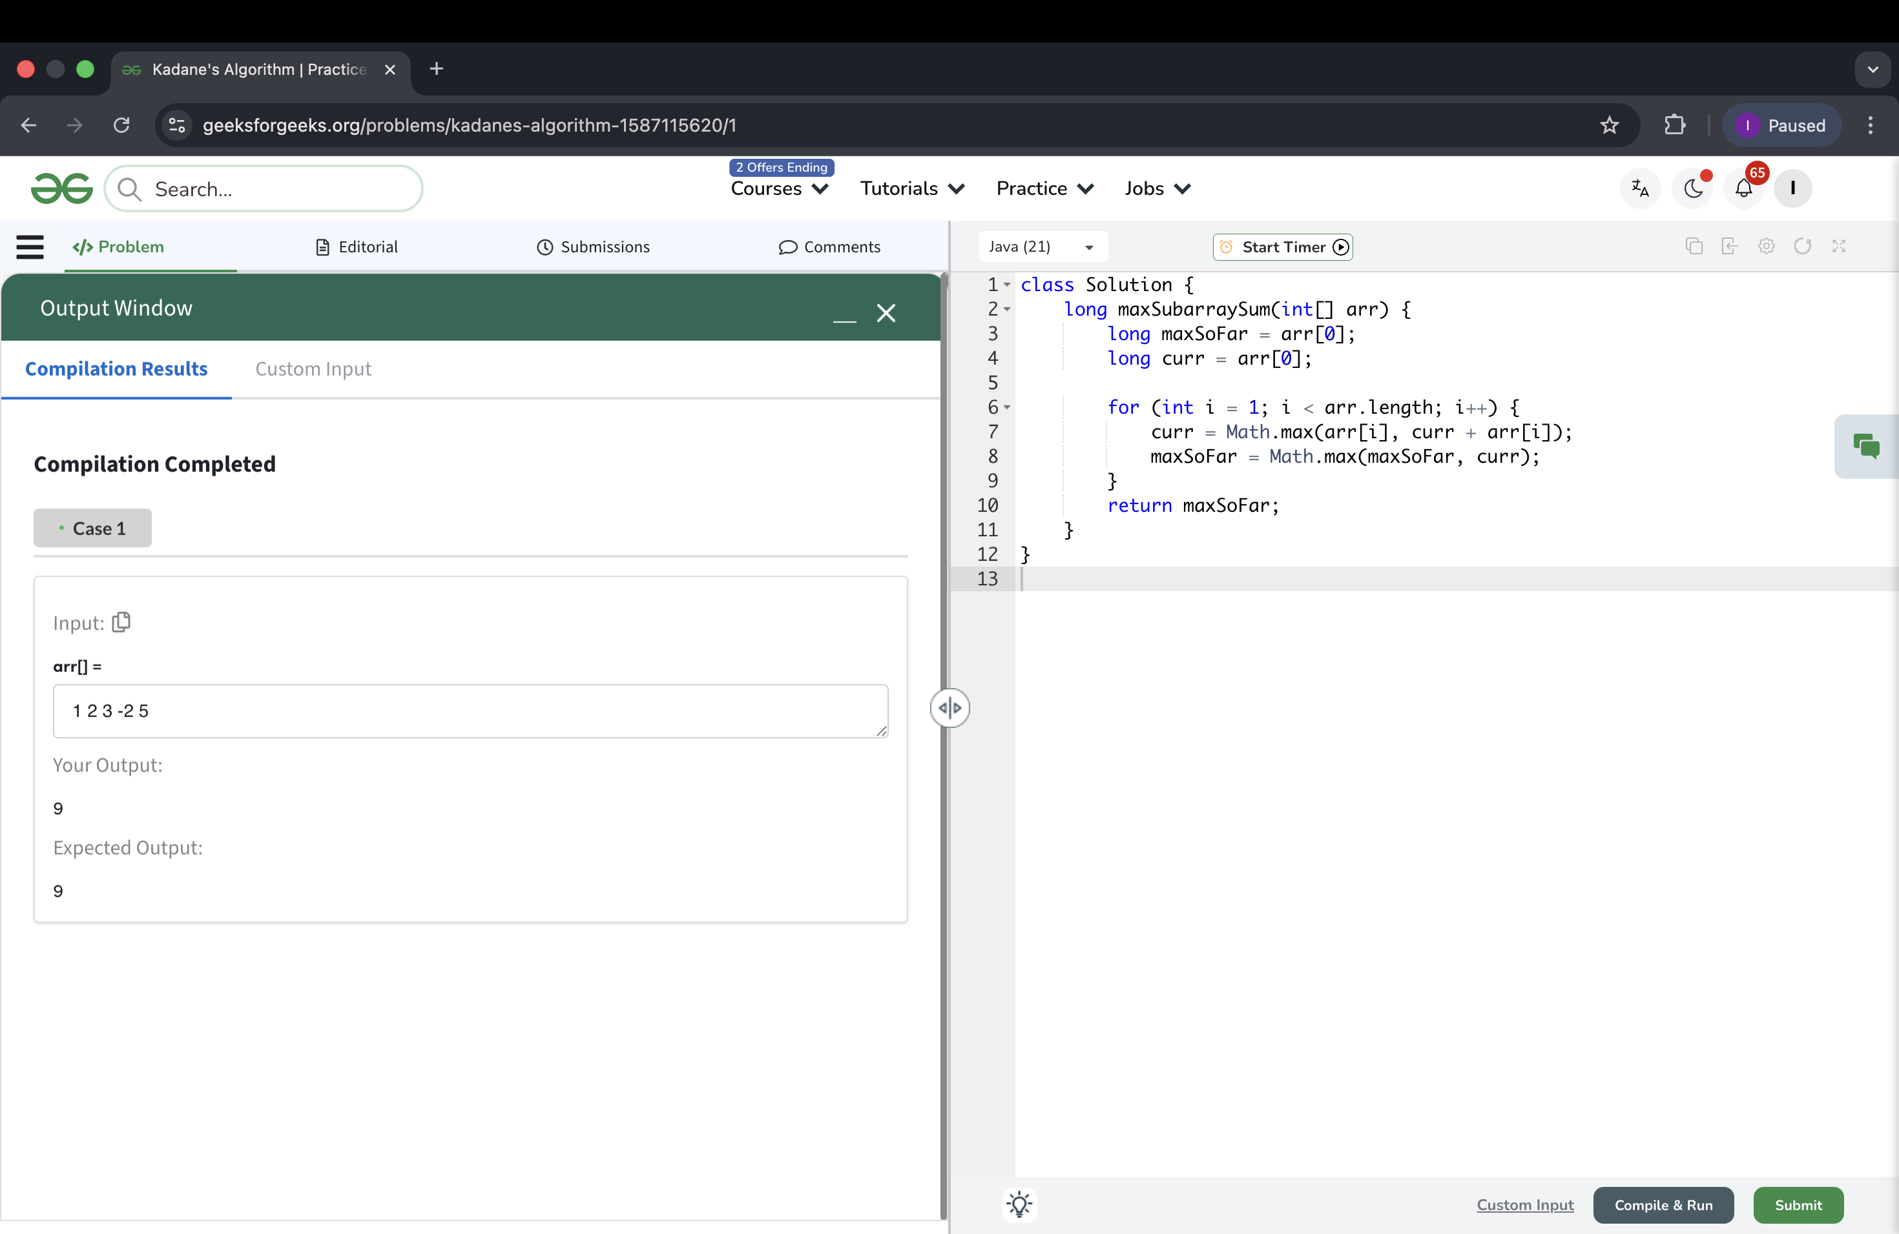

EXPERIMENT 3
Given a sorted array of distinct integers and a target value, return the index if the
target is found. If not, return the index where it would be if it were inserted in
order.
You must write an algorithm with O(log n) runtime complexity.
Example 1:
Input: nums = [1,3,5,6], target = 5
Output: 2
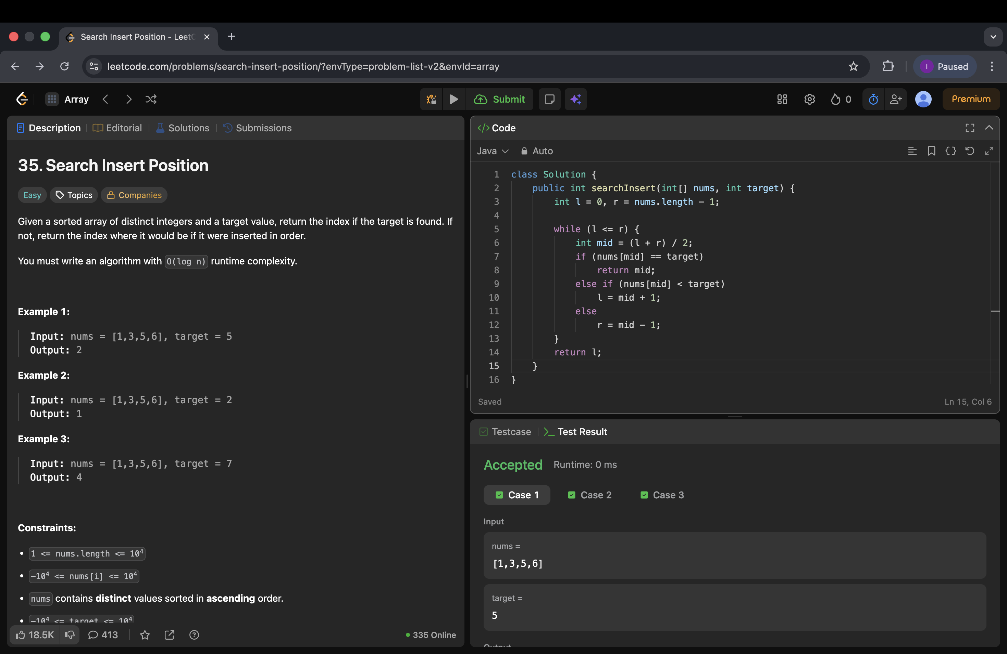
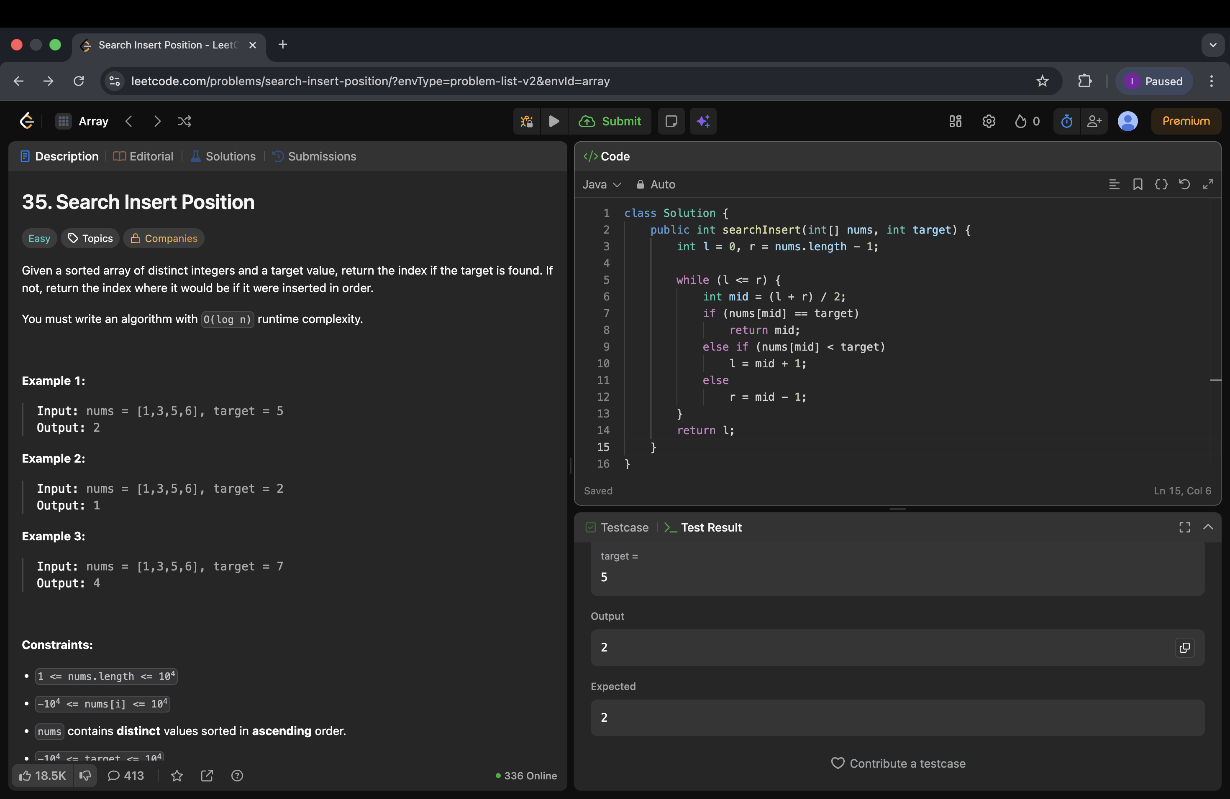

EXPERIMENT 4
Given an array of integers nums and an integer target, return indices of the two
numbers such that they add up to target.
You may assume that each input would have exactly one solution, and you may
not use the same element twice.
You can return the answer in any order.
Example 1:
Input: nums = [2,7,11,15], target = 9
Output: [0,1]
Explanation: Because nums[0] + nums[1] == 9, we return [0, 1].
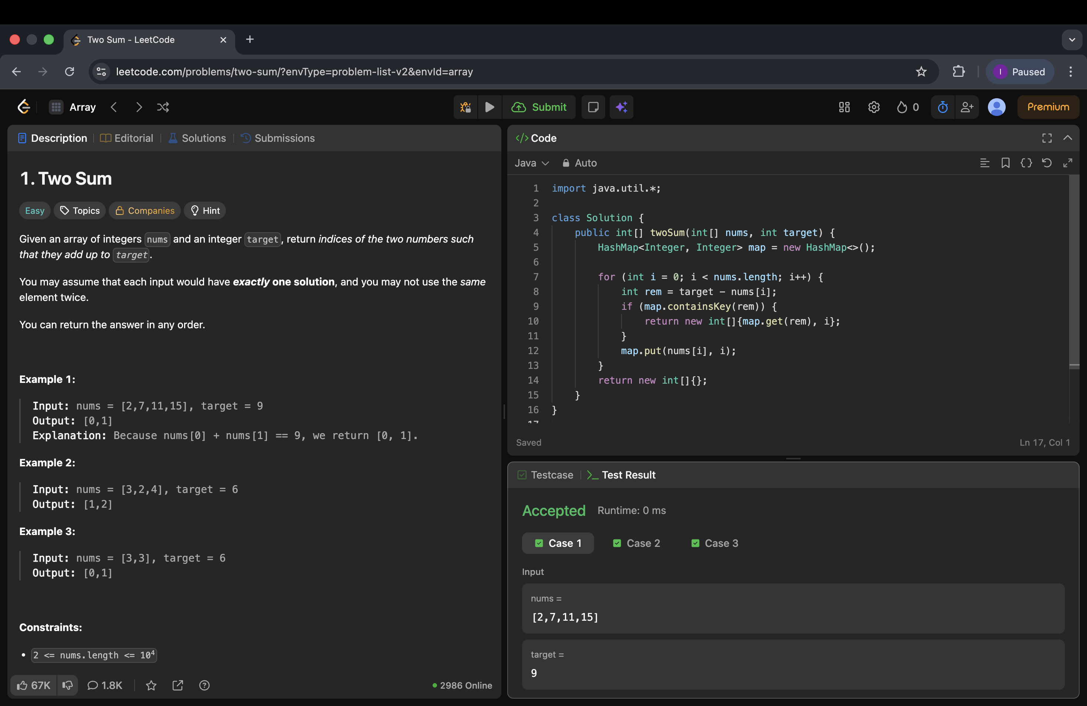
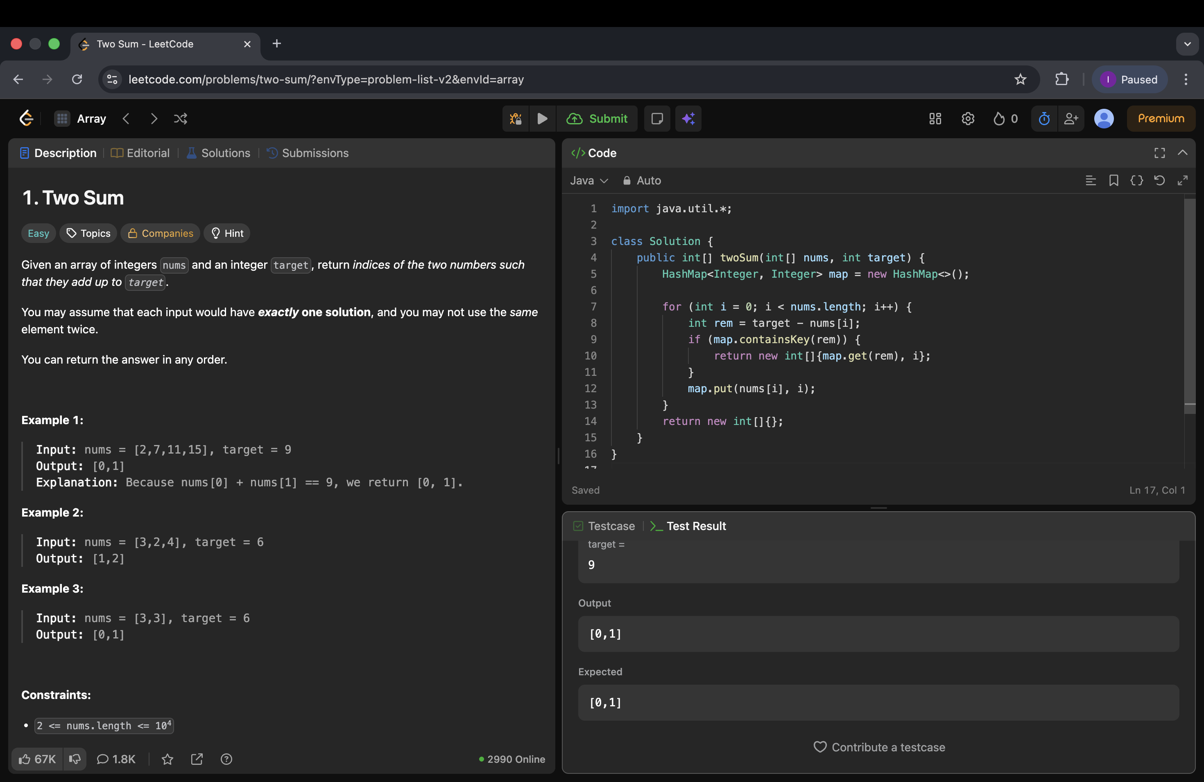

EXPERIMENT 5
You are given an array arr[] of non-negative numbers. Each number tells you
the maximum number of steps you can jump forward from that position.
For example:
• If arr[i] = 3, you can jump to index i + 1, i + 2, or i + 3 from position i.
• If arr[i] = 0, you cannot jump forward from that position.
Your task is to find the minimum number of jumps needed to move from
the first position in the array to the last position.
Note: Return -1 if you can't reach the end of the array.
Examples :
Input: arr[] = [1, 3, 5, 8, 9, 2, 6, 7, 6, 8, 9]
Output: 3
Explanation: First jump from 1st element to 2nd element with value 3. From here
we jump to 5th element with value 9, and from here we will jump to the last.
